
Story

Date | 26 August 2026
Team ID | Individual
Project Name | India's Agricultural Crop Production Analysis
Maximum Marks | 5 Marks

A Tableau data story was created to present the agricultural analysis in a clear and logical sequence. It helps users understand India's crop production from 1997 to 2021 through different story points and visualizations.
The story covers overall production, geographic distribution, state-wise production, cultivated area, crop-wise and season-wise analysis, and year-wise production trends.

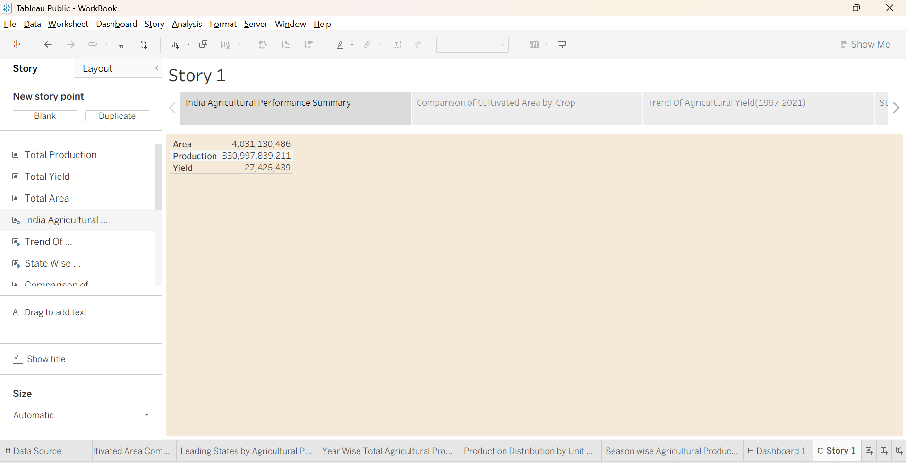

Observations
- Agricultural production varies significantly across different states.
- Karnataka is a major contributor to total production in the analysis.
- Uttar Pradesh has the highest cultivated area among the major states analyzed.
- Rice and wheat occupy significant cultivated areas in northern India.
- Cotton and soyabean are prominent crops in central and western India.
- Production changes over time and can be analyzed using the year-wise trend.

Activity 2:
Publish Story on Tableau Public and Paste Public link below
https://public.tableau.com/app/profile/vishal.bade6689/viz/WorkBook_17870655561870/Story1?publish=yes

